**DISCUSSION**

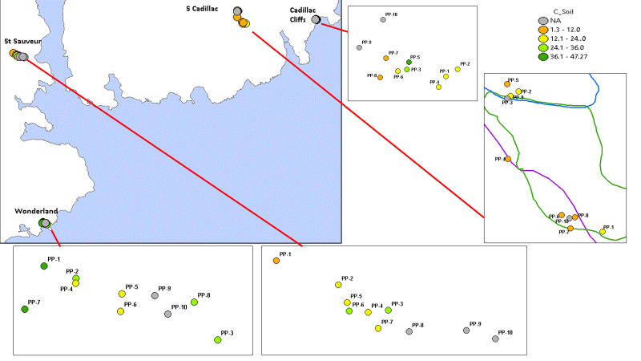A previous study (Licht and Smith 2020) examined resilience of field-grown pitch pine seedlings exposed to the influence of anthropogenic and ‘natural’ fire charcoals. Here we changed focus to resilience as an artifact of ‘disturbance versus non-disturbance’ not based solely on charcoal inputs but encapsulating photosynthesis, stand allometrics, available organic and mineral nutrition, geography and topography. According to the importance ascribed by others to the agency of fire-induced sedimentary charcoal (Patterson Edwards and Maguire 1987) fines in soil columns (Hart Horn and Grissino-Mayer 2008) at burned sites (Laing 1993) on the island, we were keen to

Figure 4 ?. Soil C (mg/kg-1) analysis comparing low and high elevation and burned and unburned pitch pine colonies

identify intra- population differences to unravel the resilience enigma. To accomplish this task we acknowledged the pivotal influence of post-pyrolysis organics on decades of seedling recruitment and rebirth stretching below the North and South summits of Cadillac Mountain stretching easterly to Bar Harbor, Southeast to Otter Creek and South towards Seal Harbor while also recognizing C availability from other decomposition sources in unburned precincts (Figure 2).

Studies reported elsewhere contrast fire presence and fire absence and the influence of charcoal on robust soil C and N enrichment (Patel *et al* 2016) at burned-over communities at Cadillac Brook (well below the heights of South Cadillac trail) which far surpasses deposits at nearby, unburned Hadlock Brook. Soil C persistence since the 1947 perturbance at Cadillac cliffs and South Cadillac trail likely reflects a failure of pyrogenic carbon removal (Doerr *et al* 2018) during and after the intense perturbance, whereas depressed soil C deposits elsewhere are conceivably attributable to greater consumption by fungi (Luo et al 2017). Carbon plays a critical role as an agent of photosynthesis and foliar response. Our work expanded on reports of foliar nutrient effects and photosynthesis at Wonderland (Butak 2014). We concluded there was a trend toward higher foliar nutrient at lower elevations consistent with the earlier Wonderland results, and affirmation of more substantial δ13C at higher elevations. Taken together with soil moisture retention outcomes, we established preliminary evidence of a relation between high elevations, more negative δ13C and moisture availability reported by others (Wang et al 2017; Chen, Wang and Jia 2017) but a firm understanding of the role of fire and its charcoal products in this calculus remains elusive.

Limiting factors within the confines of South Cadillac trail and Cadillac cliffs provide further clues as to niche capacity, biogeography and post-fire effects (Verma and Jayakumar 2012). P concentrations, in particular, appear to play an important role in pitch pine resilience at Mt. Desert; and what is most intriguing is the possible influence of elevation at Mt. Desert as opposed to more uniform topography at other pinelands (Renninger et al 2013; Alkañiz *et al* 2018). Not surprisingly we were anxious to clarify why P sorption was so prominent in fire zone soils at South Cadillac trail in the light of diminished growth there. We suspect an explanation for enhanced P availability is linked to organics derived from charcoal remnants but we did not conduct mycorrhizal studies to confirm if this was indeed a stimulus for liberating this mineral. As to N, scientists suggest acidified deposits may account for increased N deposition (Doerr *et al* 2018) as for example in fire-torn western pine forests (Pingree and DeLuca 2017). Nevertheless, we discovered lower foliar % N at Cadillac South trail than elsewhere and chalk post-fire loss to an ongoing lack of N sorption resulting from atmospheric N release. Within pitch pine communities in New Jersey Pine Barrens, investigators assert N is taken up by ectomycorrhizal pitch pine roots (Luo et al 2017) but there is some debate as to whether N in the form of NO3- is taken up by pitch pines at a meaningful level (Certini 2005). We lacked access to quantify those indicators at Mt. Desert, but propose mineralization rates constitute a proxy for root N uptake, as others have asserted in δ15N measurement in pitch pine ecosystems (Inglett et al 2007). We were unable to account for comparatively greater soil 15N at unburned sites (St. Sauveur, Wonderland) similar to Norumbega Mountain, a portion of North Cadillac Mountain trail and lower South Cadillac trail.

Of the two factors, elevation gradients and fire effects, we found the former was a more reliable predictor of dbh. Elevation differences do not provide a complete explanation to allow an unraveling of the allometric portion of the enigma, yet they do provide clues about intra-population differences such as higher concentrations of soil Ca, K, Mg, P, Al and Zn. Elevation-wise if not fire-wise, our findings at Mt. Desert are consistent with reports from the New Jersey Pine Barrens (Mikita-Barbato *et al* 2015; Schafer and Bohrer 2016). Further, we considered Mg and trace metal Zn (responsible for growth, enzyme and carbohydrate formation) micronutrient pulses at Mt. Desert thought to be associated with bedrock weathering according to an earlier report (Butak 2014). Our research confirms Mg, an immobile and essential plant system contributor, and Zn, which among other qualities adds to cold tolerance (Contosta et al 2020), grow fainter away from the coastline, up towards mountain summits consistent with another investigation (Kolker *et al* 2013). Closer to Acadia, we compared fire-exposed soils at Waterboro Barrens in York Country ME (Copenheaver White and Patterson 2000) with those at Mt. Desert. Allowing for differences between the two communities, the authors found C and K alkali extractions were significantly higher for the Waterboro Barren cohort, with a decidedly greater disparity in available P, a limiting factor which tallied with % N (.39)—this amount is 50% higher than the measurement at Cadillac South trail. These results stimulate further interest in comparing off-island pitch pine preserves with those at Mt. Desert.

Warming climate is a significant concern. Recent climate change models anticipate negative impact on the arc of future vegetative status at Mt. Desert (Fernandez et al 2015) but the model does not specifically address the vicissitudes of pitch pine. Day Greenwood and White (2001) found an uptick in annual temperatures signaled increased leaf-air vapor pressure deficits, which negatively impact pitch pine stomata response and limit gas exchange. It is likely warming trends increase pitch pine difficulties in reproduction (Ledig Smouse and Hom 2015) and the effects of ‘mesophication’—negative feedback for shade intolerant trees (Nowacki and Abrams 2008). The same may apply to niche expansion (Day *et al* 2005), where loss of open space, a lack of fecund substrates and ‘safe sites’ are most problematic. Generally, it is agreed the lack of suitable habitat perhaps based on fire absence may be the most important predictor of pitch pine consolidation, regeneration or migration (Lee et al 2019). Despite upbeat assessments and proscriptions for encouraging certain species over others in an effort to somehow replicate pine barrens of the past (Bried Patterson and Gifford 2014), at Mt. Desert, at any rate, this is not desirable, nor even possible, given a lack of evidence to authentically fathom stand fire dynamics from hundreds let alone thousands of years in the past.

Other weather-related effects influence stand status, including episodic drought, harsh winds and salt spray (Schmitt 2015; Fernandez et al 2015), cold intolerance (Berang and Steiner 1985) and acidic mist and fog deposition (Weathers et al 1986; Jagels et al 2002). A recent paper (Fernandez *et al* 2015) outlines current and projected increases in mean annual temperatures linked to meteorological factors. There is reason to believe nutrient aerosols trapped providentially in foliage, or accumulating in weathered bedrock, at lower elevation, are important contributors to pitch pine ecosystem stability based on a recent study (Butak 2014). Still, much needs to be learned about the influence of marine aerosol foliar and bedrock deposition, and whether these serve as compensatory mechanisms in place of fire (Evans 2018).

Finally, decreases in annual winter temperatures coupled with an absence of fire are a cause for concern about a quite different threat—that is the potential invasion within the next decade of a bark beetle, namely Southern pine beetle (*Dendroctonus frontalis* Zimmer). This pest (SPB) is already making its presence known in Massachusetts, Rhode Island and Connecticut to the south (Dodds et al 2018). Unless its progress is deterred by other insect predators (Coulson and Klepzig 2011) like a double checkered clerid (*Thanasimus dubius*), it is quite possible that pitch pines along with understory plants, butterflies and moth members of the Acadia ecosystem will suffer the same fate as others experienced in more southerly locations (Lesk et al 2017).

CONCLUSION

We conclude there are several discernable factors which lead to the resilience of pitch pine trees unassociated with the 1947 Mt. Desert island conflagration, especially topographic gradients, foliar and edaphic nutrient availability and soil moisture retention. Our study appears to be the first to achieve this understanding using remote sensing technology to integrate collection, treatment and analyte interpretation. Pitch pines with a one-hundred-year fire absence history, or longer, were found to allocate more energy to growth than stress resistance amidst worsening biotic and abiotic pressures. We conclude individuals within observed populations demonstrate resilience through other secondary factors such as the letting go of fire adaptations and selective retreat to avoid competitors. This study unravels some of the enigmatic persistence experienced by a globally rare species whose contemporary success provides insight to forest managers charged with preserving the future of these remarkable trees in age of fire absence.